**LINEAR PROGRAMMING REVISION – LEO’S LAUNDROMAT**

The clothes dryers at Leo’s Laundromat can be either coin- or token-operated. Leo is considering how many clothes dryers should be coin-operated and how many should be token-operated.

Each coin-operated clothes dryer generates income of $1000 per month.

Each token-operated clothes dryer generates income of $800 per month.

He has space at his Laundromat for up to 40 clothes dryers. Coin- and token-operated clothes dryers take up the same amount of space.

The current demand for token-operated clothes dryers means that Leo must have at least twice as many token-operated clothes dryers than coin-operated clothes dryers.

He has an ongoing contract with the company that makes the tokens, and needs to have at least 10 token-operated clothes dryers at his Laundromat.

The diary that sells the tokens is not open 24 hours a day, so he needs to have at least 6 coin-operated clothes dryers at his Laundromat.

Leo’s income per month from the clothes dryers is given by the function:

*Income =* 1000*c* + 800*t*

Use the information to calculate how many coin-operated and token-operated clothes dryers Leo should install at his Laundromat to maximise his monthly income.

**Step 1: Write inequations**

This information may be useful (one equation per statement):

*He has space at his Laundromat for up to 40 clothes dryers*

*Leo must have at least twice as many token-operated clothes dryers than coin-operated clothes dryers.*

*At least 10 token-operated*

*At least 6 coin-operated*

**Step 2: Draw Axis**

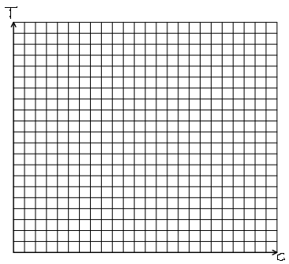

**Step 3: Draw lines**

**Step 4: Shade out**

**Step 5: Find vertices of the feasible region**

( , ) ( , ) ( , ) ( , )

**Step 6: Find the maximum profit**

This information may be useful:

*Income =* 1000*c* + 800*t*

**Step 6: Write a statement answering the question.**

Leo should buy …